**India General Elections Result Analysis 2024**

**Database Name: India_Election_Result**

**Used Table :  
See the imported tables:**

SELECT * FROM constituencywise_details;

SELECT * FROM constituencywise_results;

SELECT * FROM partywise_results;

SELECT * FROM states;

SELECT * FROM statewise_results;

**Total Seats:**SELECT DISTINCT COUNT(Parliament_Constituency) AS Total_Seats FROM constituencywise_results;

**What is the total number of seats available for elections in each state**

SELECT

s.State,

count(cr.Parliament_Constituency) as No_of_Seats

FROM

constituencywise_results as cr

JOIN

statewise_results as sr

ON

cr.Parliament_Constituency = sr.Parliament_Constituency

JOIN

states as s

ON

sr.State_ID = s.State_ID

GROUP BY s.State

ORDER BY s.State;

**Total Seats Won by NDA Allianz(National Democratic Alliance)**

**Outcome**: The NDA secured a clear majority in the 18th Lok Sabha, winning **293 of 543 seats**—with the BJP winning 240 and its allies contributing the rest

SELECT

SUM(CASE

WHEN party IN (

'Bharatiya Janata Party - BJP',

'Telugu Desam - TDP',

'Janata Dal (United) - JD(U)',

'Shiv Sena - SHS',

'AJSU Party - AJSUP',

'Apna Dal (Soneylal) - ADAL',

'Asom Gana Parishad - AGP',

'Hindustani Awam Morcha (Secular) - HAMS',

'Janasena Party - JnP',

'Janata Dal (Secular) - JD(S)',

'Lok Janshakti Party(Ram Vilas) - LJPRV',

'Nationalist Congress Party - NCP',

'Rashtriya Lok Dal - RLD',

'Sikkim Krantikari Morcha - SKM'

) THEN Won

ELSE 0

END) AS NDA_Total_Seats_Won

FROM

partywise_results

**Seats Won by NDA Allianz Parties**

SELECT

Party,

Won AS Seats_Won

FROM partywise_results

WHERE Party IN (

'Bharatiya Janata Party - BJP',

'Telugu Desam - TDP',

'Janata Dal (United) - JD(U)',

'Shiv Sena - SHS',

'AJSU Party - AJSUP',

'Apna Dal (Soneylal) - ADAL',

'Asom Gana Parishad - AGP',

'Hindustani Awam Morcha (Secular) - HAMS',

'Janasena Party - JnP',

'Janata Dal (Secular) - JD(S)',

'Lok Janshakti Party(Ram Vilas) - LJPRV',

'Nationalist Congress Party - NCP',

'Rashtriya Lok Dal - RLD',

'Sikkim Krantikari Morcha - SKM'

)

ORDER BY Seats_Won DESC;

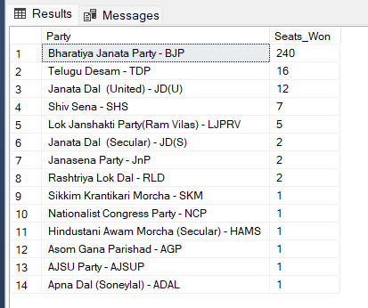

**Total Seats Won by I.N.D.I.A. Allianz**

**Outcome : The Indian National Developmental Inclusive Alliance (I.N.D.I.A.) secured 234 out of 543 seats in the 2024 Lok Sabha elections**

SELECT

SUM(CASE

WHEN party IN (

'Indian National Congress - INC',

'Aam Aadmi Party - AAAP',

'All India Trinamool Congress - AITC',

'Bharat Adivasi Party - BHRTADVSIP',

'Communist Party of India (Marxist) - CPI(M)',

'Communist Party of India (Marxist-Leninist) (Liberation) - CPI(ML)(L)',

'Communist Party of India - CPI',

'Dravida Munnetra Kazhagam - DMK',

'Indian Union Muslim League - IUML',

'Nat`Jammu & Kashmir National Conference - JKN',

'Jharkhand Mukti Morcha - JMM',

'Jammu & Kashmir National Conference - JKN',

'Kerala Congress - KEC',

'Marumalarchi Dravida Munnetra Kazhagam - MDMK',

'Nationalist Congress Party Sharadchandra Pawar - NCPSP',

'Rashtriya Janata Dal - RJD',

'Rashtriya Loktantrik Party - RLTP',

'Revolutionary Socialist Party - RSP',

'Samajwadi Party - SP',

'Shiv Sena (Uddhav Balasaheb Thackrey) - SHSUBT',

'Viduthalai Chiruthaigal Katchi - VCK'

) THEN Won

ELSE 0

END) AS INDIA_Total_Seats_Won

FROM

partywise_results

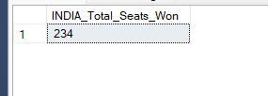

**Seats Won by I.N.D.I.A. Allianz Parties:**

SELECT

Party ,

Won as Seats_Won

FROM

partywise_results

WHERE

party IN (

'Indian National Congress - INC',

'Aam Aadmi Party - AAAP',

'All India Trinamool Congress - AITC',

'Bharat Adivasi Party - BHRTADVSIP',

'Communist Party of India (Marxist) - CPI(M)',

'Communist Party of India (Marxist-Leninist) (Liberation) - CPI(ML)(L)',

'Communist Party of India - CPI',

'Dravida Munnetra Kazhagam - DMK',

'Indian Union Muslim League - IUML',

'Nat`Jammu & Kashmir National Conference - JKN',

'Jharkhand Mukti Morcha - JMM',

'Jammu & Kashmir National Conference - JKN',

'Kerala Congress - KEC',

'Marumalarchi Dravida Munnetra Kazhagam - MDMK',

'Nationalist Congress Party Sharadchandra Pawar - NCPSP',

'Rashtriya Janata Dal - RJD',

'Rashtriya Loktantrik Party - RLTP',

'Revolutionary Socialist Party - RSP',

'Samajwadi Party - SP',

'Shiv Sena (Uddhav Balasaheb Thackrey) - SHSUBT',

'Viduthalai Chiruthaigal Katchi - VCK'

)

ORDER BY Seats_Won DESC;

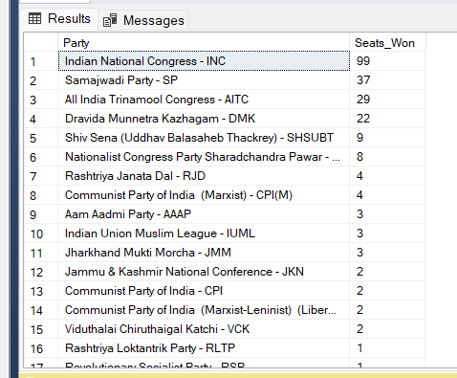

**Add new column field in table partywise_results to get the Party Allianz as NDA, I.N.D.I.A and OTHER**

ALTER TABLE partywise_results

ADD Party_Alliance VARCHAR(50);

**I.N.D.I.A Allianz:**

UPDATE partywise_results

SET Party_Alliance = 'I.N.D.I.A'

WHERE Party IN (

'Indian National Congress - INC',

'Aam Aadmi Party - AAAP',

'All India Trinamool Congress - AITC',

'Bharat Adivasi Party - BHRTADVSIP',

'Communist Party of India (Marxist) - CPI(M)',

'Communist Party of India (Marxist-Leninist) (Liberation) - CPI(ML)(L)',

'Communist Party of India - CPI',

'Dravida Munnetra Kazhagam - DMK',

'Indian Union Muslim League - IUML',

'Jammu & Kashmir National Conference - JKN',

'Jharkhand Mukti Morcha - JMM',

'Kerala Congress - KEC',

'Marumalarchi Dravida Munnetra Kazhagam - MDMK',

'Nationalist Congress Party Sharadchandra Pawar - NCPSP',

'Rashtriya Janata Dal - RJD',

'Rashtriya Loktantrik Party - RLTP',

'Revolutionary Socialist Party - RSP',

'Samajwadi Party - SP',

'Shiv Sena (Uddhav Balasaheb Thackrey) - SHSUBT',

'Viduthalai Chiruthaigal Katchi - VCK'

);

**NDA Allianz:**

UPDATE partywise_results

SET Party_Alliance = 'NDA'

WHERE party IN (

'Bharatiya Janata Party - BJP',

'Telugu Desam - TDP',

'Janata Dal (United) - JD(U)',

'Shiv Sena - SHS',

'AJSU Party - AJSUP',

'Apna Dal (Soneylal) - ADAL',

'Asom Gana Parishad - AGP',

'Hindustani Awam Morcha (Secular) - HAMS',

'Janasena Party - JnP',

'Janata Dal (Secular) - JD(S)',

'Lok Janshakti Party(Ram Vilas) - LJPRV',

'Nationalist Congress Party - NCP',

'Rashtriya Lok Dal - RLD',

'Sikkim Krantikari Morcha - SKM'

);

**OTHER:**

UPDATE partywise_results

SET Party_Alliance = 'OTHER'

WHERE Party_Alliance IS NULL;

**Which party alliance (NDA, I.N.D.I.A, or OTHER) won the most seats across all states?**

SELECT

pr.Party_Alliance,

COUNT(cr.Constituency_ID) as Seats_Won

FROM constituencywise_results cr

JOIN

partywise_results pr

ON

cr.Party_ID = pr.Party_ID

GROUP BY Party_Alliance

ORDER BY Seats_Won DESC;

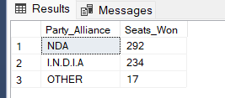

**Winning candidate's name, their party name, total votes, and the margin of victory for a specific state and constituency?**

SELECT

cr.Winning_Candidate,

pr.Party,

cr.Total_Votes,

cr.Margin,

s.State,

cr.Constituency_Name

FROM constituencywise_results cr

JOIN

partywise_results pr

ON cr.Party_ID = pr.Party_ID

JOIN

statewise_results sr

ON cr.Parliament_Constituency = sr.Parliament_Constituency

JOIN

states s

ON sr.State_ID = s.State_ID

WHERE s.State = 'Odisha' AND cr.Constituency_Name = 'KEONJHAR';

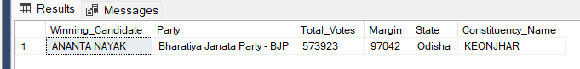

**What is the distribution of EVM votes versus postal votes for candidates in a specific constituency?**

SELECT

cr.Constituency_Name,

cd.Candidate,

cd.Party,

cd.EVM_Votes,

cd.Postal_Votes,

cd.Total_Votes

FROM constituencywise_details cd

JOIN

constituencywise_results cr

ON

cd.Constituency_ID = cr.Constituency_ID

WHERE cr.Constituency_Name = 'KEONJHAR'

ORDER BY cd.Total_Votes DESC;

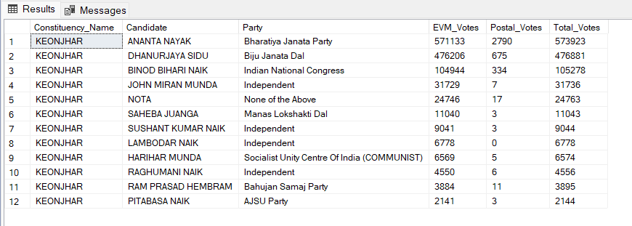

**Which parties won the most seats in s State, and how many seats did each party win?**

SELECT

pr.Party,

COUNT(cr.Constituency_ID) AS Seats_Won

FROM

constituencywise_results cr

JOIN

partywise_results pr

ON

cr.Party_ID = pr.Party_ID

JOIN

statewise_results sr

ON

cr.Parliament_Constituency = sr.Parliament_Constituency

JOIN states s

ON

sr.State_ID = s.State_ID

WHERE

s.state = 'Odisha'

GROUP BY

pr.Party

ORDER BY

Seats_Won DESC;

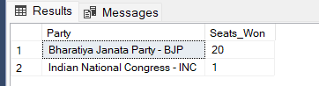

**What is the total number of seats won by each party alliance (NDA, I.N.D.I.A, and OTHER) in each state for the India Elections 2024**

SELECT

s.State,

SUM(CASE WHEN pr.Party_Alliance = 'NDA' THEN 1 ELSE 0 END) AS NDA_Seats_Won,

SUM(CASE WHEN pr.Party_Alliance = 'I.N.D.I.A' THEN 1 ELSE 0 END) AS INDIA_Seats_Won,

SUM(CASE WHEN pr.Party_Alliance = 'OTHER' THEN 1 ELSE 0 END) AS OTHER_Seats_Won

FROM constituencywise_results cr

JOIN partywise_results pr

ON cr.Party_ID = pr.Party_ID

JOIN statewise_results sr

ON cr.Parliament_Constituency=sr.Parliament_Constituency

JOIN states s

ON sr.State_ID = s.State_ID

GROUP BY s.State

ORDER BY s.State;

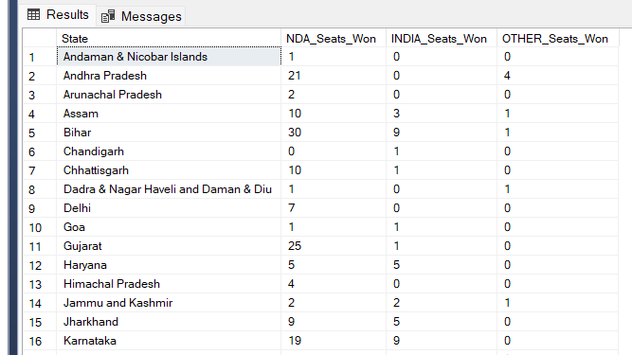

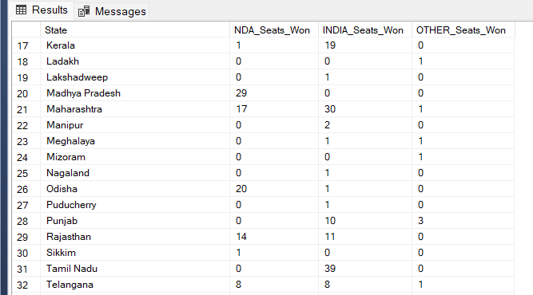

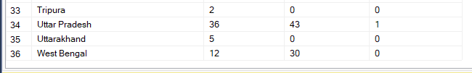

**Which candidate received the highest number of EVM votes in each constituency (Top 10)?**

SELECT TOP 10

cr.Constituency_Name,

cd.Constituency_ID,

cd.Candidate,

cd.Party,

cd.EVM_Votes

FROM

constituencywise_details cd

JOIN

constituencywise_results cr

ON cd.Constituency_ID = cr.Constituency_ID

ORDER BY cd.EVM_Votes DESC;

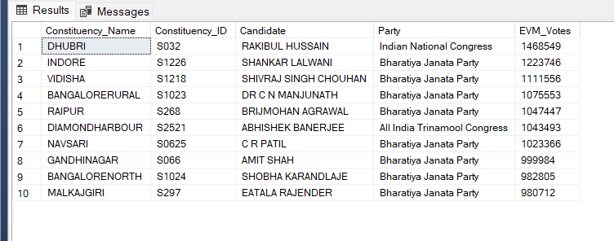

**For the state of Odisha, what are the total number of seats, total number of candidates, total number of parties, total votes (including EVM and postal), and the breakdown of EVM and postal votes?**

SELECT

COUNT(DISTINCT cr.Constituency_ID) AS Total_Seats,

COUNT(DISTINCT cd.Candidate) AS Total_Candidates,

COUNT(DISTINCT p.Party) AS Total_Parties,

SUM(cd.EVM_Votes + cd.Postal_Votes) AS Total_Votes,

SUM(cd.EVM_Votes) AS Total_EVM_Votes,

SUM(cd.Postal_Votes) AS Total_Postal_Votes

FROM

constituencywise_results cr

JOIN

constituencywise_details cd

ON cr.Constituency_ID = cd.Constituency_ID

JOIN

statewise_results sr

ON cr.Parliament_Constituency = sr.Parliament_Constituency

JOIN

states s

ON sr.State_ID = s.State_ID

JOIN

partywise_results p

ON cr.Party_ID = p.Party_ID

WHERE

s.State = 'Odisha';

